Scottish Government

Issued on behalf of
The Local Government Boundary Commission for Scotland
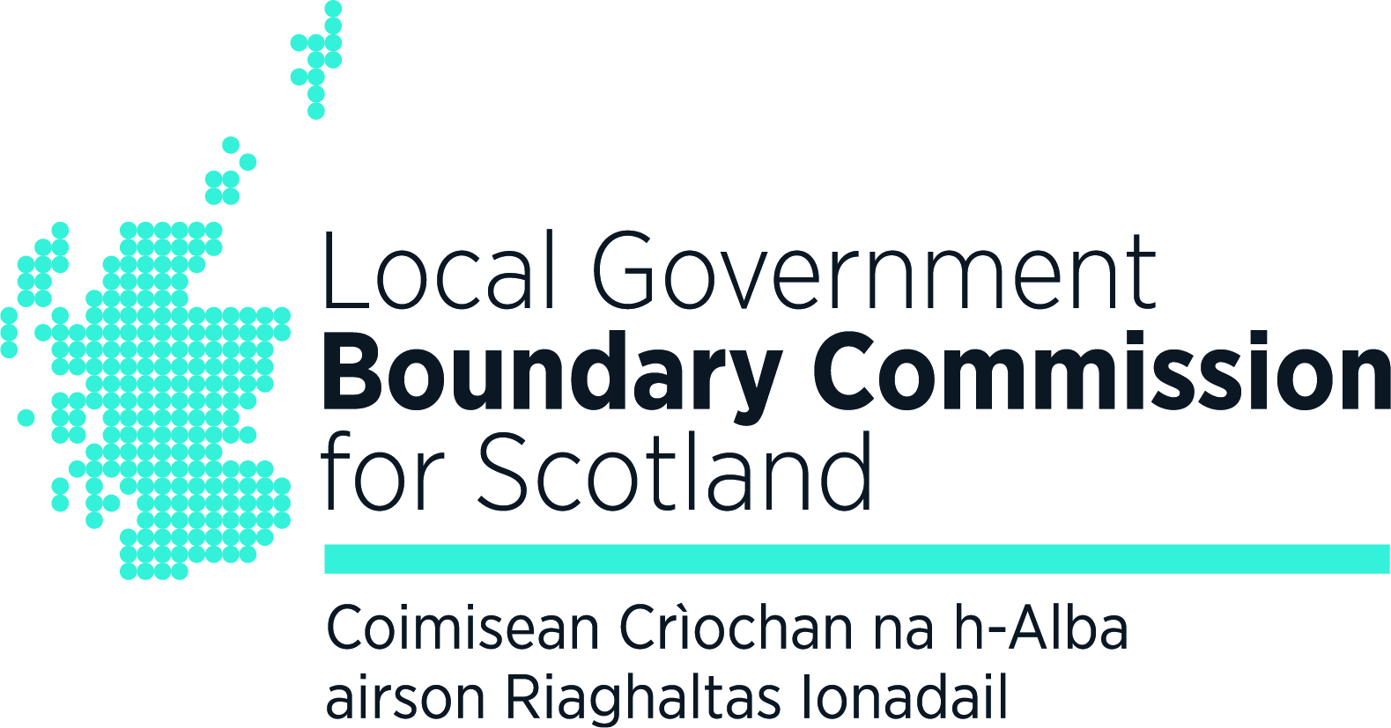
Not for Publication or Broadcast
before 0001 Hours on 1 October 2019

Consultation on proposed Scottish Parliament Boundary changes at Cardowan by Stepps

The Local Government Boundary Commission for Scotland is seeking the public’s views on proposed changes to the Scottish Parliament constituency boundary between Glasgow Provan constituency and Coatbridge and Chryston constituency, and the Scottish Parliament region boundary between Glasgow region and Central Scotland region, at Cardowan by Stepps. The consultation ends on 31 October 2019.

Comments on these proposed changes can be submitted through our consultation portal www.consult.lgbc-scotland.gov.uk by e-mail to comments@scottishboundaries.gov.uk or in writing to: Thistle House, 91 Haymarket Terrace, Edinburgh EH12 5HD.

The proposed changes are in response to changes to the boundary between North Lanarkshire and Glasgow City council areas in this vicinity in April 2019. The Scottish Parliament constituency and region boundaries near Cardowan now differ from the administrative area boundary between Glasgow City and North Lanarkshire council areas.

The proposed changes, will affect around 300 electors, and will allow the Scottish Parliament constituency and region boundaries to be aligned with the council area boundary in time for the next Scottish Parliament elections in May 2021.

The Local Government Boundary Commission for Scotland will make recommendations from this review to the Secretary of State in 2020.

Further information on the review can be found on the Commission’s consultation portal : www.consult.lgbc-scotland.gov.uk

*** ends ***

Notes for News Editors

The Local Government Boundary Commission for Scotland is an independent advisory non-departmental public body sponsored and wholly funded by the Scottish Government. The role of the Commission is to review the electoral boundaries of the Scottish Parliament and administrative and electoral boundaries relating to Scottish council areas.

Full information about the Commission and its work is available on the Commission’s website: http://lgbc-scotland.gov.uk/. A general introduction to the Commission and its work appears in our Information Paper The Commission: a general guide which is available from the Publications section of the website http://lgbc-scotland.gov.uk/. Information on this review is available from the Reviews in Progress section of the website: http://lgbc-scotland.gov.uk/

Contact for Further Information:
Isabel Drummond-Murray
Secretary to the Local Government Boundary Commission for Scotland

Tel: 0131 244 2001
Mobile: 07770 735056
Isabel.Drummond-Murray@scottishboundaries.gov.uk
lgbc-scotland.gov.uk/

